**BCI Lab Report 3**

### Section 4. Show the effect of subject behavior on alpha power. Bandpass (8-12Hz)

Low Pass Effect on Alpha Power:

| LP | **Closed Eyes** | **Alpha Blocking** | **Relaxed** |
| --- | --- | --- | --- |
| .1Hz |  |  |  |
|  | | | |
| .5Hz |  |  |  |
|  | | | |
| 1Hz |  |  |  |
|  | | | |

* Alpha power was on average highest during the closed eyes trials. This is what we would expect to see as alpha power is seen during early sleep stages.

### Section 5. Examine the effect of the low pass filter’s cut-off frequency that is changing with alpha power

* We began by defining a 95% threshold to be met for the convergence analysis. The convergence speed was calculated by measuring the time it took for the mean signal to settle within 95% of its final value.
* Then we measured smoothness based on calculating its second derivative (the derivative of the velocity, which is the acceleration), and taking the norm of this derivative over time.
* We expect to determine which Low Pass filter leads to a smoother signal as a smoother signal will have smaller accelerations, leading to a lower norm.

| **.1Hz** | | **.5Hz** | **1Hz** |
| --- | --- | --- | --- |
|  | |  |  |
| **Convergence Speed** | 101-102 | 140 | 245-534 |
| **Smoothness** | 2.51-2.6 | 1.44 | 4.03-4.04 |

* From the results on the table shown above we determined that the fastest convergence speed was seen with the 0.1 Hz low pass filter. We also determined that the smoothest curve was seen with the 0.5 Hz low pass filter.

Convergence Speed

* 0.1 Hz low pass filter showed the fastest convergence speed (101-102) which suggests that the signal under the 0.1 Hz low-pass filter setting stabilizes very quickly. This could be because the filter effectively removes higher frequency fluctuations, which typically take longer to stabilize, leaving primarily slow, stable components in the signal.

Smoothness

* The smoothness values are higher (2.51-2.6) than at 0.5 Hz but lower than at 1 Hz. This likely means that while the signal converges quickly, it still has some minor fluctuations.
* The 0.5 Hz low pass filter showed the lowest smoothness values (1.44), indicating the most uniform rate of change.
* This might be the optimal balance between removing high-frequency noise and retaining the essential dynamics of the signal, leading to a smoother output!

### Section 6. Show the theta band effect you observe when trying the 3 subject behaviors

Changing Bandpass to Theta Band (4-7Hz)

* Change the numerator of the divide function to the theta instead of the alpha leaving the denominator the same

| **Eyes Closed** | **Alpha Blocking** | **Relaxation** |
| --- | --- | --- |
|  |  |  |

* The theta band effect seen reflects the highest theta power concentrated during alpha blocking, for which we did quick addition problems. This resulted in the highest theta power as during alpha blocking, the brain compensates by increasing activity in other bands, such as theta. Quick addition problems can elevate cognitive processing, thereby increasing theta activity.

### 

### Section 7. Does the auditory (or other) feedback help your subject control their alpha power?

* Implement a way to visualize the output (we did sound)
  + 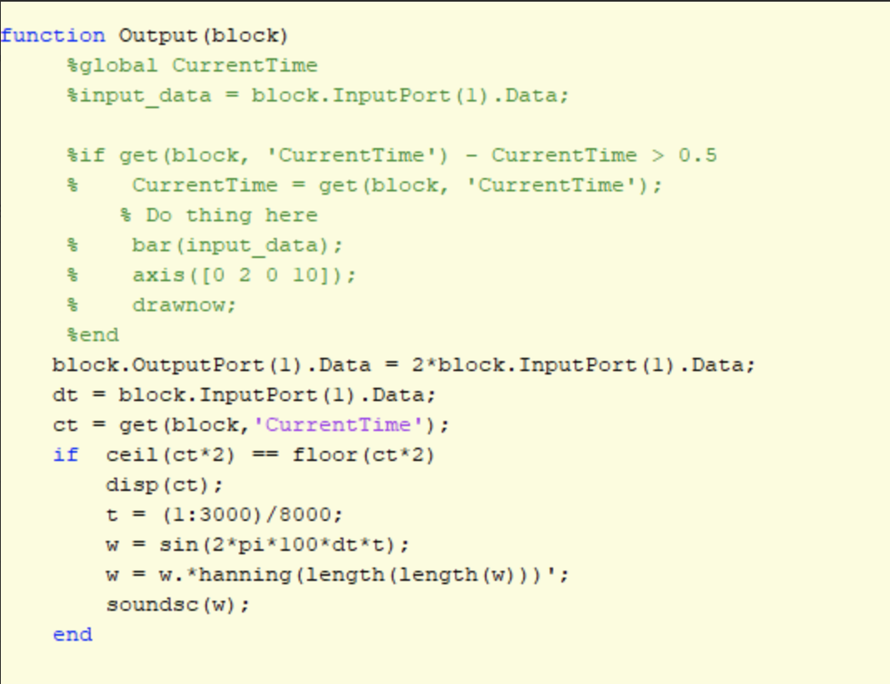
  + We found that it was difficult but significantly easier to improve once we had an auditory signal that we could use to try to increase the alpha power. However because the tone was so distracting it was also difficult to relax which in turn also made it difficult to control.
* Alpha power aka the mean is channel #13

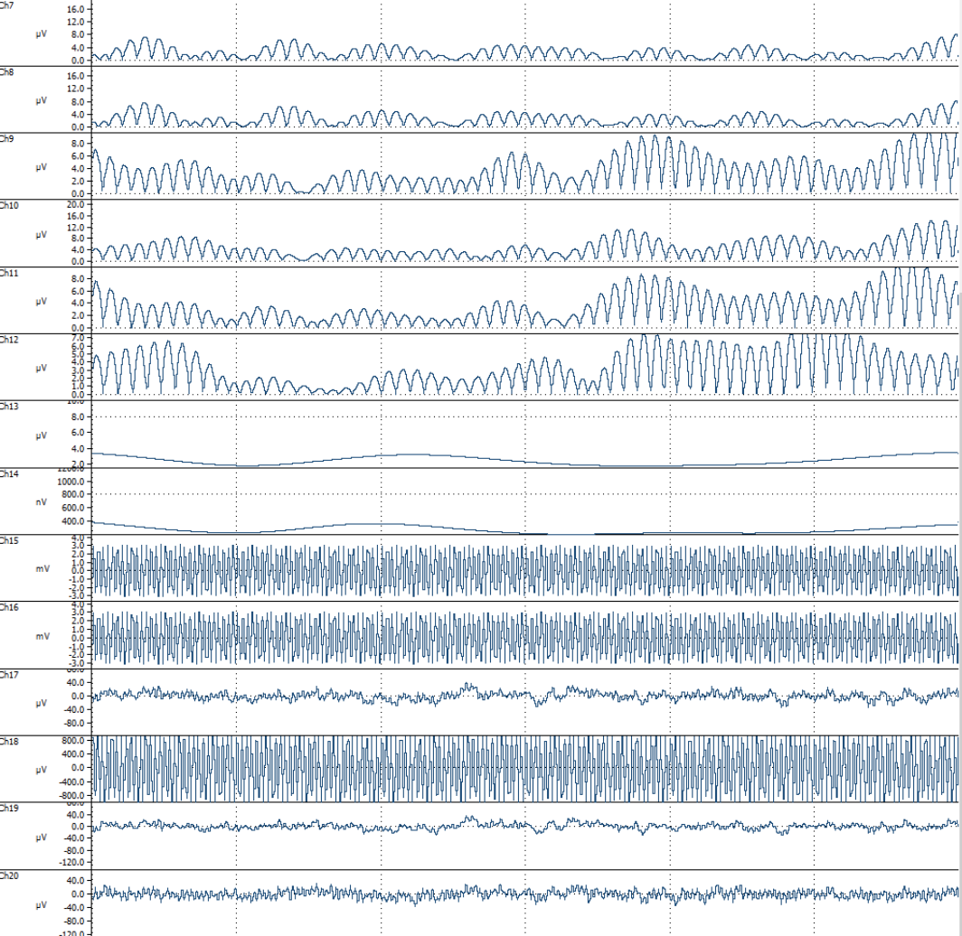

### Section 8. Is the alpha-theta ratio easier to control than alpha or theta alone?

* Change the bandpasses to be alpha divided by theta
* The order on the simulink is ratio, theta envelope, alpha envelope
* You will want to check the divide term to see how well you can control it and you should compare it to channel #13 from the last step

|  |  |
| --- | --- |

* Yes! The ratio of alpha and theta was much easier to control than alpha alone.